**Exercise 3**

**Question 1:**

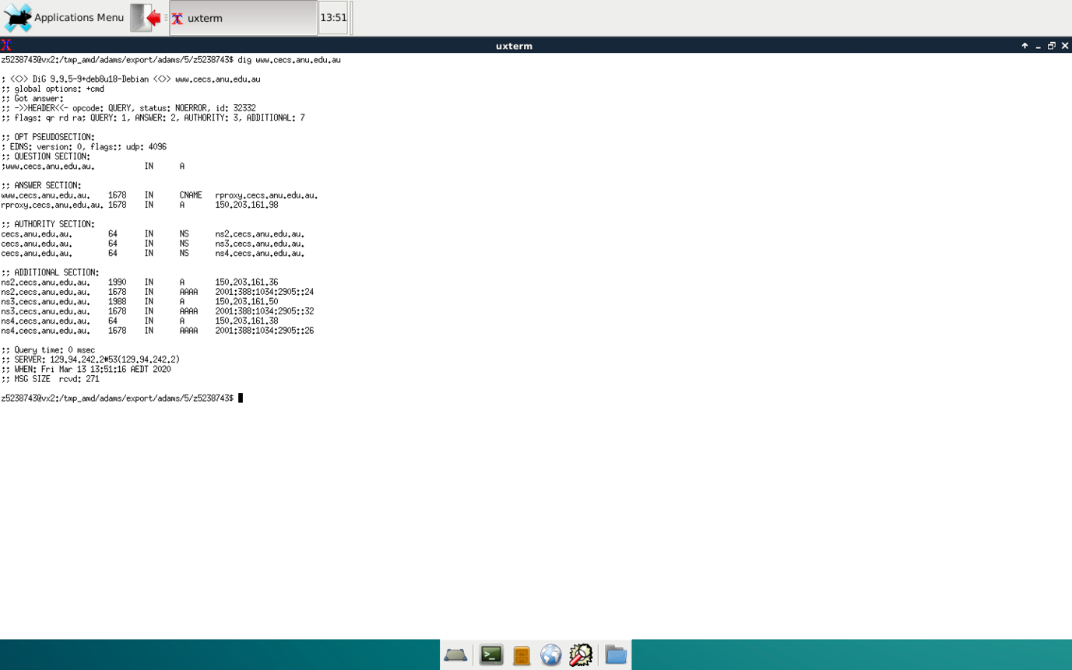

Figure 3.1

From figure 3.1, the IP address of [www.cecs.anu.edu.au](http://www.cecs.anu.edu.au/) is 150.203.161.98.  type of A DNS query is sent to get this answer

**Question 2:**

From figure 3.1, the canonical name for the CECS ANU web server is rproxy.cecs.anu.edu.au.

The reason is that host aliasing which exist are easy to help human remember, however, host aliasing doesn’t have host detailed information.

**Question 3:**

From figure 3.1, the authority section contains NS Resources Record(RR) and the type is NS,

The Name is cecs.anu.edu.au which is a domain name. The Value is ns2.cecs.anu.edu.au, ns3.cecs.anu.edu.au, ns4.cecs.anu.edu.au, all of which are three authoritative name servers.

The additional section contains three IP address for three domain servers and the type is A.

Besides, type of AAAA are for IPV6 addresses.

**Question 4:**

From figure 3.1, the IP address of the local nameserver for your machine is 129.94.242.2

**Question 5:**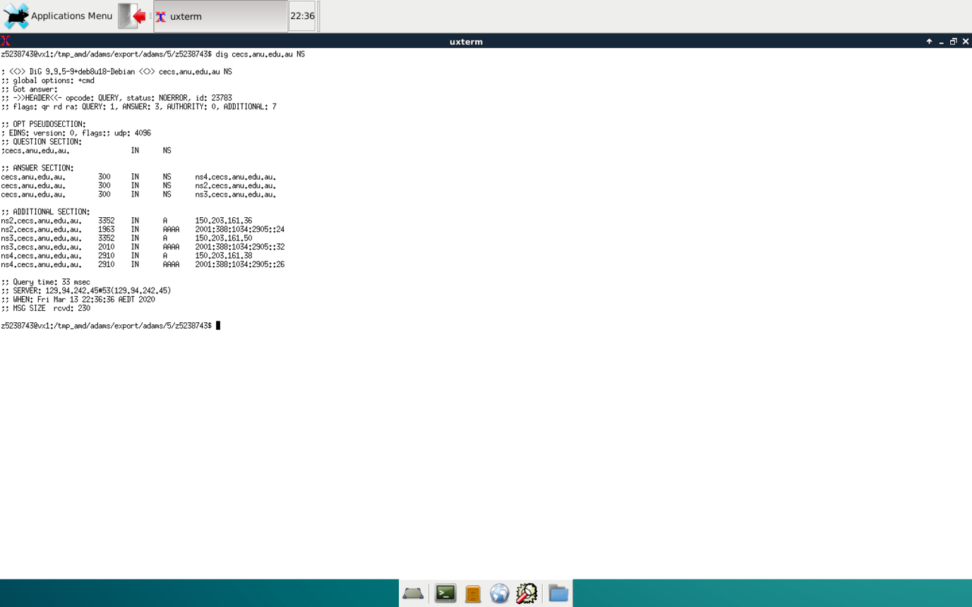

Figure 3.2

From figure 3.2, the DNS nameservers for the “cecs.anu.edu.au” domain are ns4.cecs.anu.edu.au, ns2.cecs.anu.edu.au and ns3.cecs.anu.edu.au. Their IP addresses are 150.203.161.36 , 150.203.161.50 and 150.203.161.38 respectively. The type of DNS query is sent to obtain this information is NS.

**Question 6:**

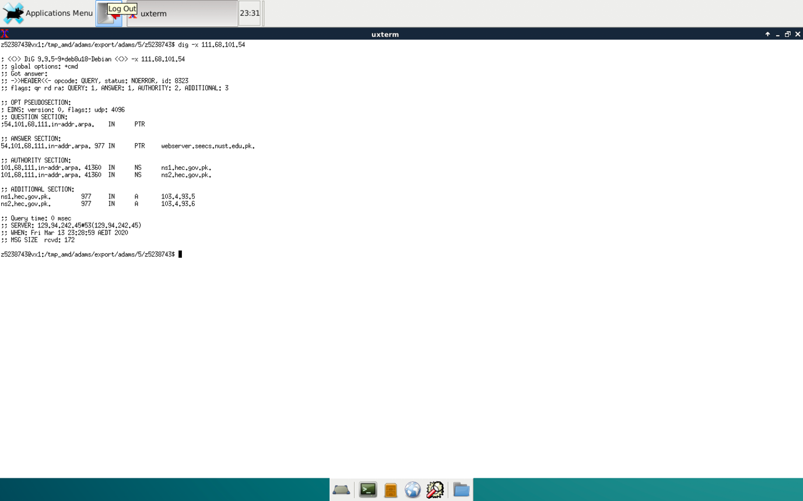

Figure 3.3

From figure 3.3, the DNS name are webserver.seecs.nust.edu.pk

Type of DNS query is sent to obtain this information are reverse query.

**Question 7:**

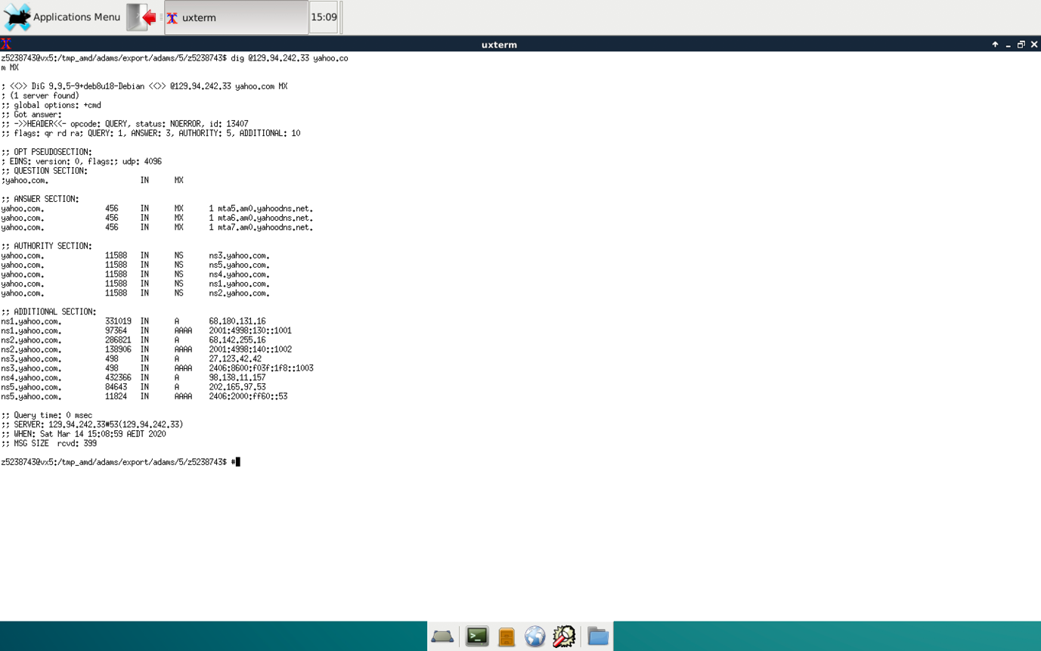

Figure 3.4

From figure 3.4, I don’t get an authoritative answer, because the response that show in flags doesn’t have aa which represent the authoritative answer. This is because this server has authority for cse.unsw.edu.au domain and not for yahoo domain.

**Question 8:**

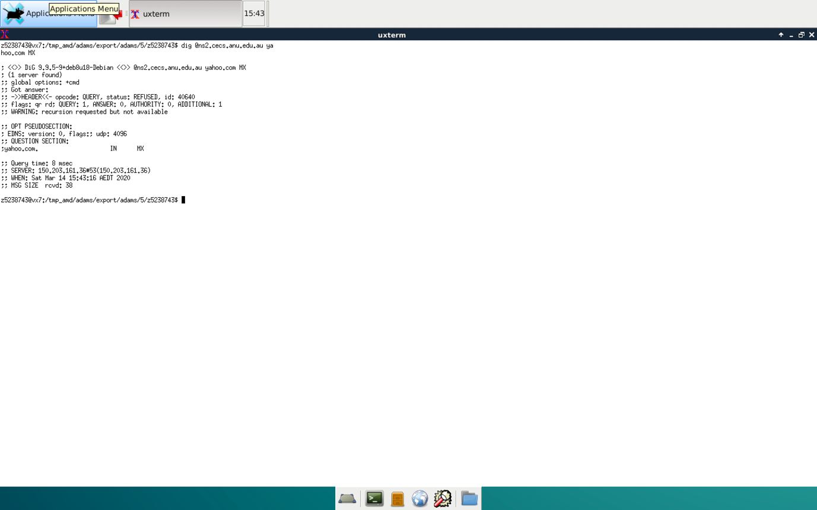

Figure 3.5

From figure 3.5, I don’t get a response. The warning: recursion requested but not available. The reason may be these nameservers don’t reply to DNS queries that sent from devices that are not part of ANU network.

**Question 9:**

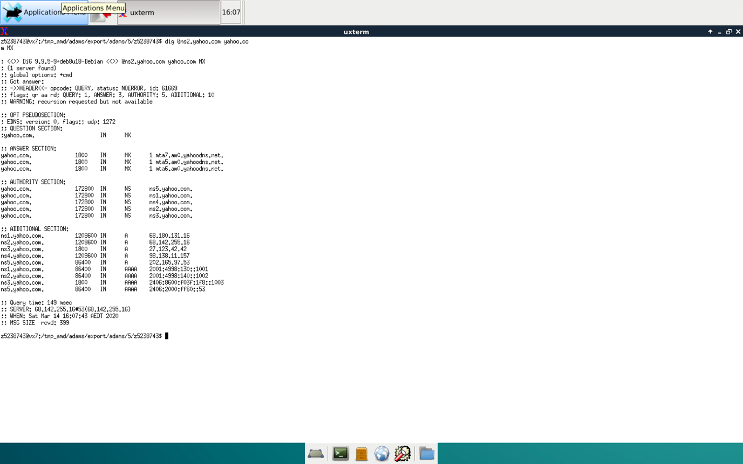

Figure 3.6

From figure 3.6, the type of DNS query is sent to obtain this information is MX

**Question 10:**

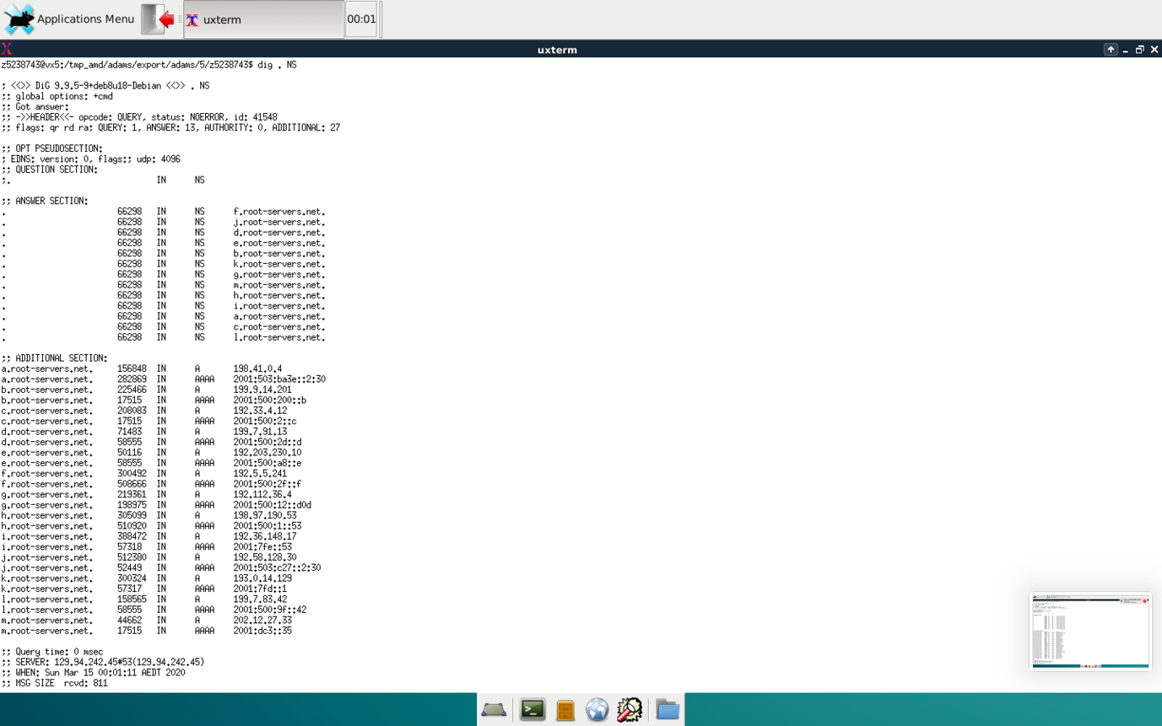

Figure 3.7

I find the authoritative name server for the "au." Domain of this nameserver is 198.41.0.4 and assuming that I sit in drum02.

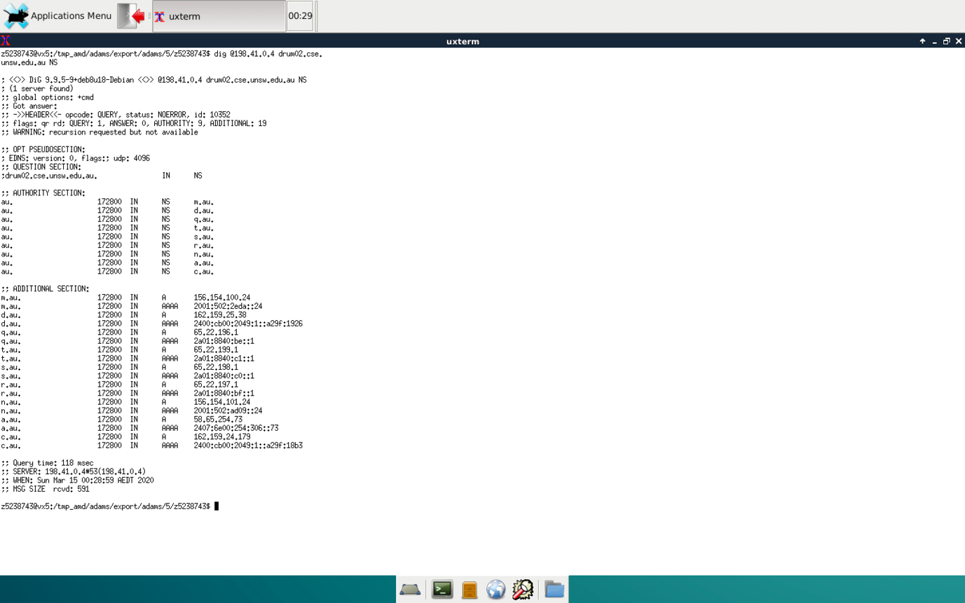

Figure 3.8

Then I refer to the .au nameservers, so query one of them:

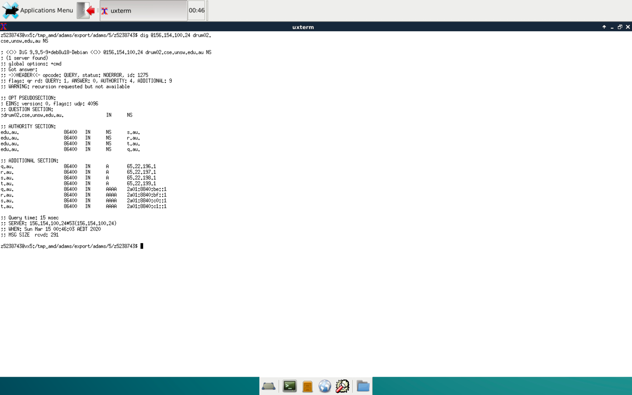

Figure 3.8

Then I refer to the edu.au nameservers, so query one of them:

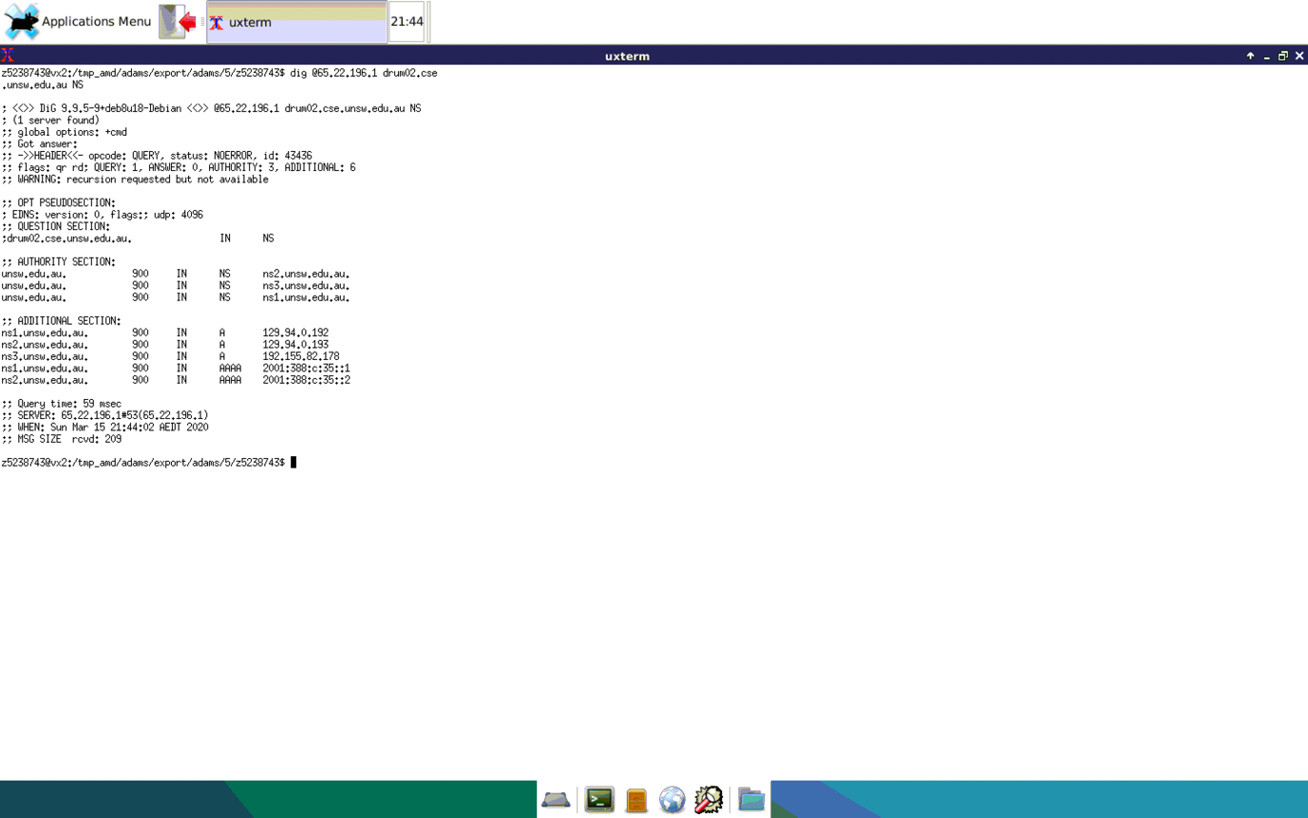

Figure 3.9

Then I refer to the edu.au nameservers, so query one of them:

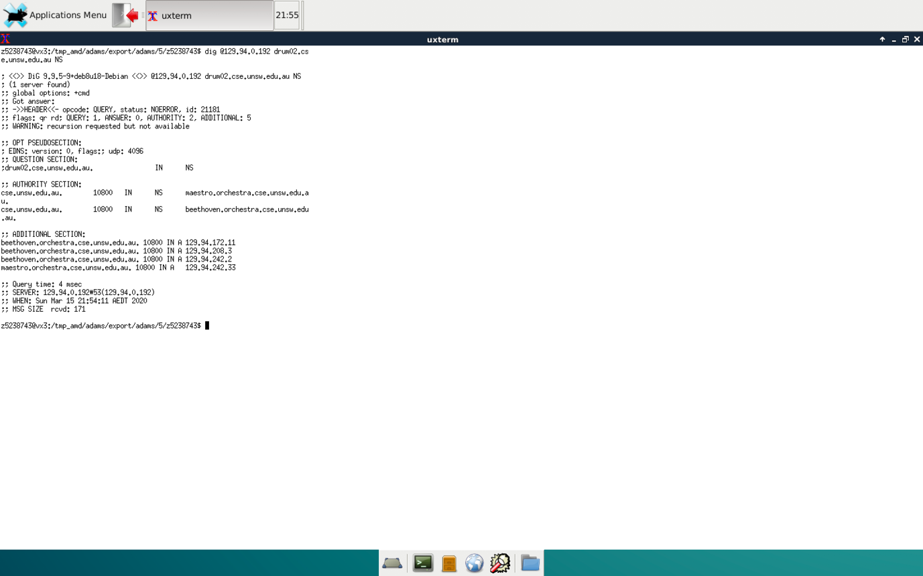

Figure 3.9

NOW UNSW CSE nameservers has been referred. Then I use type A query, so query one of them. From Figure 3.10, the answer is 129.94.209.32

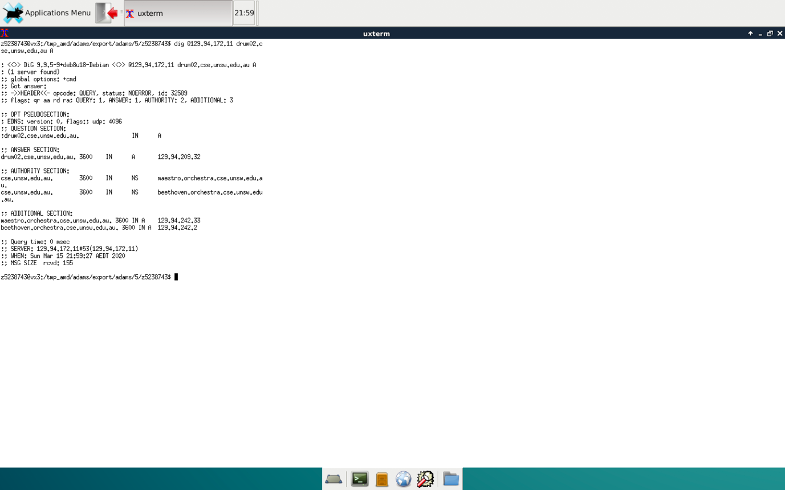

Figure 3.10

**Question 11:**

One physical machine can have several names and/or IP addresses associated with it. A machine can have several network interface which can have several IP addresses associated with it. Besides IP address can have few hostname.

**Exercise 4**